# **Machine Learning System Flowcharts and algorithms**

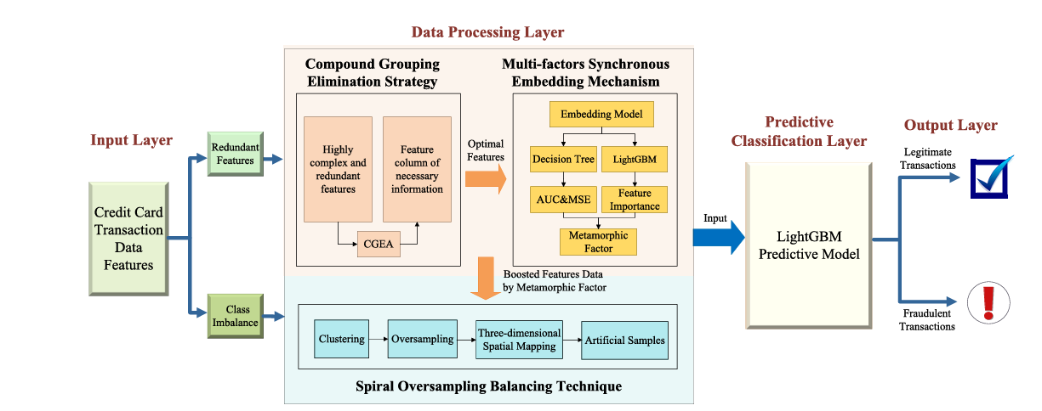

### CGEA

### MSEF Boast Algorithm

### SBOT (Spiral Oversampling Balancing Technique)

Light GBM model should be applied for of the modeling of the fraud detection.

RFE

Step indexing.